



TABLE OF CONTENTS

1. ABOUT The Company
2. Analyst Ratings
3. Analyst Suggestions
4. Business Segments
5. Revenue Classification Historical
6. Business Risk
7. Competitive Advantages
8. SWOT Analysis .
9. Financial Analysis .
10. . Valuation .

11. Trade Comparable

12.Appendix

➢ Discounting Cashflow .

➢ Trading Comparable

1. ABOUT THE COMPANY

Uber Technologies, Inc. is a prominent global technology company, primarily recognized for its ride-hailing service, Uber, which enables users to request a ride via a smartphone app. Established in 2009 by Garrett Camp and Travis Kalanick, Uber has expanded its offerings beyond ridesharing to include services like food delivery through Uber Eats, freight logistics via Uber Freight, and even the development of autonomous vehicles and electric bikes. Operating in many countries.

IT has changed the way people navigate urban environments and has broadened its business model to encompass additional services such as financial solutions and package delivery.

Although it faces regulatory hurdles and competition, Uber continues to be a major player in the transportation and logistics industry. The company is committed to innovation, focusing on technology, sustainability, and the expansion of its service

Uber provides a variety of products and services aimed at enhancing transportation, delivery, and logistics.

Here’s a brief overview of their main offerings:

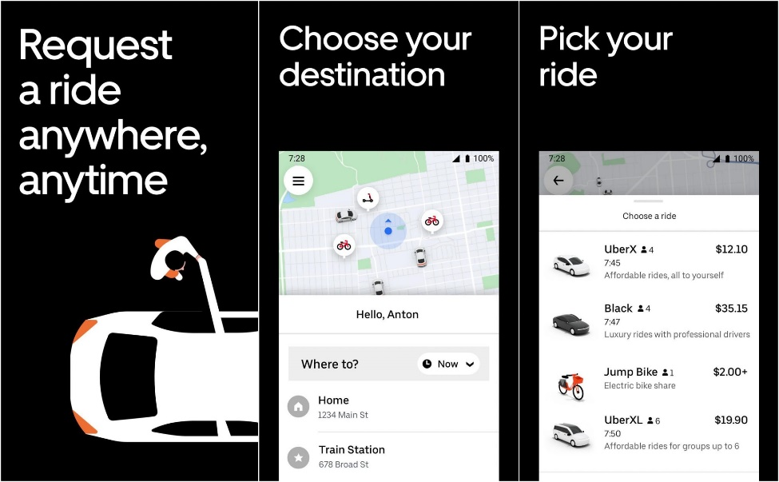

Uber Rides: The core service that lets users book rides from several options, including UberX for standard rides, UberXL for larger groups, and Uber Black for a premium experience. They also have accessible ride options for individuals with disabilities.



Uber Eats: This is a food delivery platform that allows users to order meals from nearby restaurants and have them delivered by Uber drivers, also known as "delivery partners."

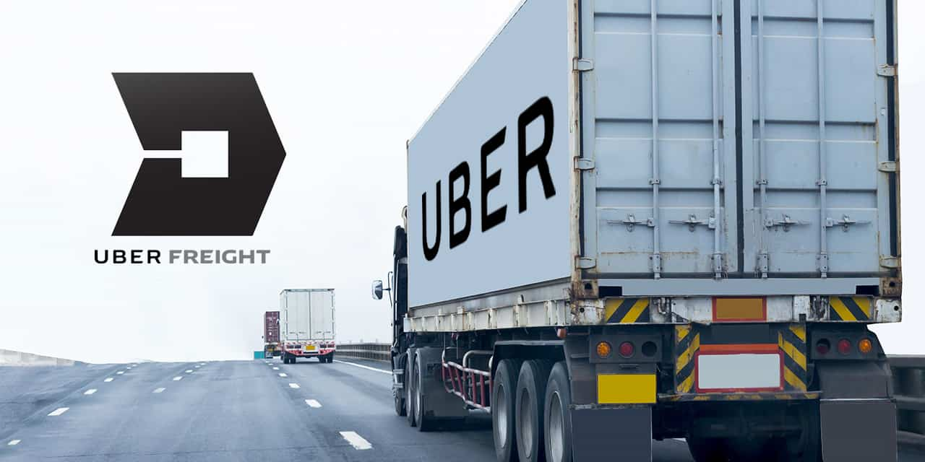

Uber Freight: A service that links truck drivers with companies needing to ship freight, optimizing the logistics process and offering a marketplace for moving goods.



Uber for Business: Specifically designed for corporate clients, this service helps businesses manage transportation needs such as employee travel and client rides.

|  |  |  |  |  |  |  |
| --- | --- | --- | --- | --- | --- | --- |
|  | MARKET PROFILE UBER | | |  |  |  |
|  | Closing price | |  |  |  | 66.85 |
|  | Currency |  |  |  |  | USD |
|  | 52 Weeks High/ Low | |  |  |  | 87/54.84 |
|  | Market Cap | |  |  |  | 140.77 billion |
|  | O/S Shares in (Mn) | |  |  |  | 21.88 |
|  | EV/ Sales |  | |  |  | 3.29 |
|  |  |  |  |  |  |  |

1. ANALYST RATING

At the time of writing UBER technologies traded at $ 66.85, the forecasted Enterprise value $74 to $79.7 Per share which implies there is potential raise in the value in long term and due to increase in revenue and other factors the exit multiple is more than the stock price at $79.7 which may be achieve in upcoming yrs due to growing demand . there is expected upside of 33% as per current scenario by analysts forecasts so I have issued BUY Rating for Uber technologies they are constantly working in service market and bringing newest services like Uber EV, Moto and having constant growth in revenue these are strong reasons for a Buy.

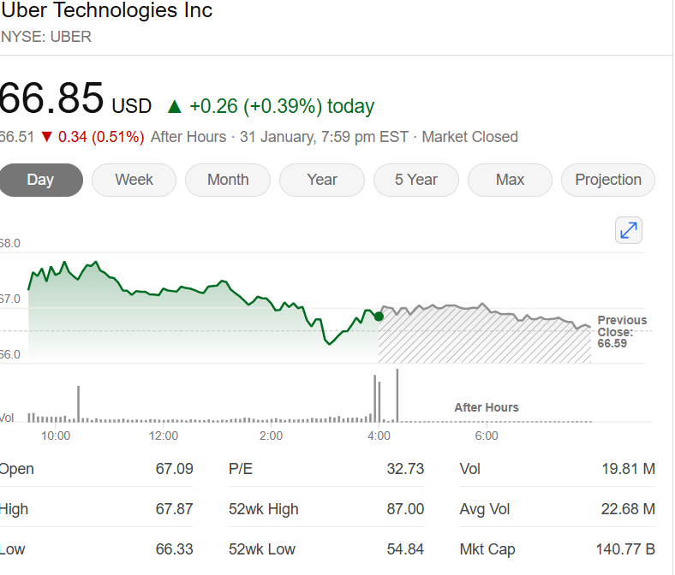

1. ANALYST SUGGESTIONS

AS per the Analyts forecast there would be annual growth rate of 22% as per consensus report of Market screener compared with forecasted results upto 2026.

* The sales value of the company is having a growth in a constant rate but in a smaller amount.
* Due to some certain reasons the previous Market trends of the company is falling but the company is having the potential of growth in the future since it has tied up with NVIDIA recently for Autonomous Mobility .

1. Business Segments

Uber Segments Overview

Mobility:  
• Connects consumers with a variety of transportation modalities.  
• Offers better consumer experiences and better earnings opportunities.  
• Includes activity related to financial partnerships and advertising.  
• Participates in certain regions through minority-owned entities.  
  
Delivery:  
• Allows consumers to discover local commerce.  
• Increases consumer engagement with Uber platform.  
• Leverages earner base by increasing utilization and earnings across the network.  
• Includes Uber Direct, a white-label Delivery-as-a-Service offering to retailers and restaurants.  
Freight:  
• Revolutionizes logistics industry.  
• Powers a managed transportation and logistics network.  
• Provides an on-demand platform to automate and accelerate logistics transactions.  
• Connects Carriers with Shippers’ shipments.  
• Serves Shippers ranging from small- and medium-sized businesses to global enterprises.  
• Offers upfront, transparent pricing and the ability to book a shipment.  
• Operates principally in North America and Europe.

5.REVENUE CLASSIFICATION FOR PAST 3 YEAR:

* Growth is a substantial asset for the company, as anticipated by dedicated analysts. Within the next three years, growth is estimated to reach 56% by 2026.

The Company’s Main revenue comes from their mobility segment in U. S market where they have introduced many services in retail market.

In year 2021 the segments overall growth are having growth rate of 56% Compared to 2020.

Where their Mobility grew by 14%, Delivery by 114% and Freight 110%.

Mobility: Gradual recovery as the restrictions of the pandemic eased and people returned to using ride-hailing services.

Delivery: A huge increase in demand for food delivery, driven by the pandemic, as well as the ongoing change in consumer behavior towards more convenience and online ordering.

Freight: Rise in logistics need as the economy started to emerge from recession with businesses looking at more flexible efficient digital solutions of freight transportation.

In year 2022, Segments revenue grew up by 82.62% compared to 2021,.

Mobility : by 102%, Delivery Revenue by 30%, freight grew by 225%.

The growth in 2022 was fueled by a steady recovery from the pandemic, an expansion of service offerings, and a rising demand for delivery and logistics. Uber's capacity to adapt and scale in these expanding sectors resulted in strong performance across all segments.

In year 2023, Segmental revenue Grew Overall 17% As Comared to 2022, Mobility by 41%, Delivery by 12% freight revenue fell by 24% due to some reasons of lack of demand .

Mobility increased as demand continued to recover and services expanded. Delivery growth has slowed as the surge in pandemic-driven demand has stabilized and competition has intensified. Freight revenue declined due to supply chain issues, an economic slowdown, and rising competition.

The overall 17% growth in 2023 indicates a mixed performance, with significant gains in mobility countered by challenges in delivery and freight.

EARNING PER SHARE

As the net profit attributable to the share is increasing in a constant rate year by year, we can notice in the below table the constant rate of rise in the Earning Per Share after Dilution which has a constant return.

Diluted EPS Source : https://finance.yahoo.com/quote/UBER/financials/

|  |  |
| --- | --- |
| TTM | 2.03 |
| 31/12/2023 | 0.87 |
| 31/12/ 2022 | -4.65 |
| 31/12/2021 | -0.29 |
| 31/ 12/2020 | -3.86 |
|  |  |

NET INCOME

|  |
| --- |
| TTM 4,402,000 |
|  |
| 31-12-2023 1887000 |
|  |
| 31-12-2022 -9,141,000 |
|  |
| 31-12-2021 -496,000 |
|  |
| 31-12-2020 -6,768,000 |

Short Executive Overview by the CEO

Ten years ago, Uber was born out of a watershed moment in technology. The rise of smartphones, the advent of app stores, and the desire for on-demand work supercharged Uber’s growth and created an entirely new standard of consumer convenience. What began as “Tap a button, get a ride” has become something much more profound: ridesharing and carpooling; meal delivery and freight; electric bikes and scooters; and self-driving cars and urban aviation.

Of course, in getting from point A to point B we didn’t get everything right. Some of the attributes that made Uber a wildly successful startup—a fierce sense of entrepreneurialism, our willingness to take risks that others might not, and that famous Uber hustle—led to missteps along the way. In fact, when I joined Uber as CEO, many people asked me why I would leave the stability of my previous job for one that was anything but. My answer was simple: Uber is a once-in-a-generation company, and the opportunity ahead of it is enormous.

BUSINESS RISK:

1. Business Risks:  
   Distribution of Drivers: If drivers are classified as employees and not independent contractors, the business model and cost structure for the company would be adversely affected.  
   Competition: Uber is subject to intense competition in mobility, delivery, and logistics areas from well-established companies with low cost alternatives as well as with well-capitalized competitors in every major market.
2. Market Appeal: Attracting and retaining a critical mass of drivers, consumers, and merchants is the platform's function for market appeal. Any inability to do so, be it in competition or otherwise, makes it less appealing.  
   Brand Reputation: The reputation of Uber's brand is paramount, and adverse media coverage or a safety event will damage the social psyche, killing business opportunities.
3. Innovation and Technological Risks: The firm runs the risk of its investment in autonomous vehicle technology and AI failing to generate desired outcomes or remaining behind peers.

2. Operational Risks:  
Operational Risks: Large, fast-growing business, managing and structurally optimizing which will be a challenging task; otherwise, Uber would suffer the harm to financial performance and future potential.

Driver and User Safety: Criminal, violent, or inappropriate activity involving drivers or platform users could lead to safety incidents undermining trust in the platform.  
Workplace Culture and Employee Retention: Persistent high employee turnover, poor succession planning, or operational and cultural challenges could disrupt business operations.

Reliance on Third Parties: Uber relies heavily on third-party platforms and software providers. Disruptions in these services will negatively affect Uber's operations.

3. Legal and Regulatory Risks:  
Legal and Regulatory Challenges: Being part of the heavily regulated industry, Uber might face costs or even restricted operations in some geographies due to ongoing or new regulation.

Data Privacy and Security: Sensitive customer, driver, and employee data handling by Uber may add to the risks of privacy concerns along with potential legal cases for data breaches, unauthorized access, or other laws on privacy violations.

Regulatory Scrutiny: There is scrutiny towards the company's financial services and operations concerning their payments, which may lead to a fine or lawsuits.

Jurisdictional Barriers: There might be restrictions on jurisdictions where Uber can operate, forcing an amendment in its business model in order to support its legal admissibility in a given region.

4.Financial and Economic Risks:  
Profitability and Losses: Uber has suffered massive losses and could continue to in the near term. Profitability and loss profitability are uncertain.  
Capital and Funding Needs: Uber will require further capital for expansion, and failure to raise the capital on good terms may impair the expansion or operations.

Volatile Stock Price: Uber's stock price will be quite volatile, and investors may suffer losses in case the stock price drops drastically, or if the expected value is not met.  
Economic and Environmental Conditions: Deterioration in the economy, social unrest, extreme weather conditions, and public health disasters can impact the financial performance as people reduce demand for Uber's services.

**COMPETATIVE ADVANTAGE**

Uber has strong global brand recognition, a vast user network, and advanced technology such as real-time tracking and AI. It has scale and network effect that enables efficient pricing and service coverage. Uber has multiple revenue streams through its diverse offerings, including ride-hailing, food delivery, and logistics. Flexible driver incentives, strategic partnerships, and access to significant capital also help Uber maintain its market leadership and innovate. Its ability to adjust to the environment of regulation is a strong competitive advantage in world markets.

Uber has several key revenue streams below:  
Ride-Hailing: Revenue from passenger trips through the Uber application.  
Uber Eats: Revenue including commissions from restaurants and delivery fees in food delivery.

Uber Freight: Revenue from connecting shippers with carriers for the transportation of freight.  
Advanced Technologies: Future revenue potential from investments in autonomous vehicles and aerial transportation (Uber Elevate).

Subscription Services: Revenue from the Uber Pass and Uber for Business subscription offerings.

Other Revenue Sources: Vehicle Leasing, advertising, and affiliations with multiple companies.  
Diversified Streams of Income which Uber can acquire from both consumer and business.

SWOT ANALYSIS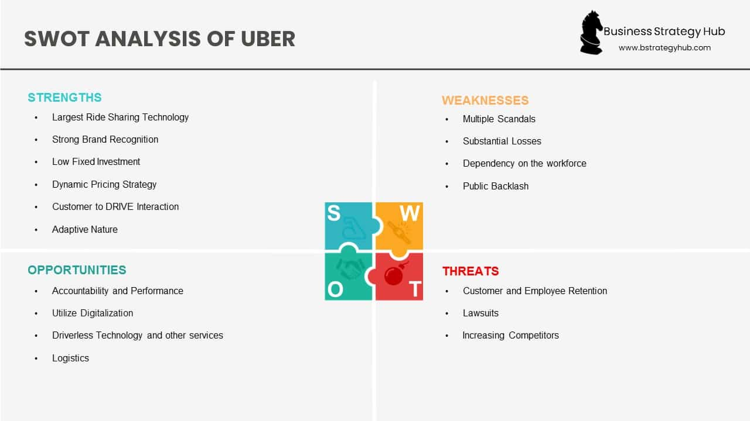

FINANCIAL ANALYSIS

REVENUE GROWTH

The revenue has been constantly increasing with 56% to 84% increasing revenue from 2021 to 2022 also with huge increase in overall revenue from downfall to 17% growth in 2023 to 59% revenue in 2024 This indicates a positive trend in revenue generation over upcoming year.

**Gross Profit /Loss**

As per the Historical scenarios uber continues to face Gross loss from operations till 2024, from 2025 it has chances of picking upto the profit Margin by 24% every YOY till 2027 and 17% in 28 as it is a growing company

VALUATIONS

**TERMINAL VALUE AND GROWTH RATE**

The terminal value calculated using Gordon growth method

stands at $ 1290478 Millions , with a Long term growth rate assumption of 3% (Acc. to United States Growth rate) .

This is the projected cash flow value of the business after the specific forecast term.

**Enterprise Value** :

According to the discounted cash flow (DCF) analysis, the operating business has an enterprise value of $1425623million, which is the present value of anticipated future cash flows.

**Total value of Firm :** Total Value of firm stands at 1425623 Million as there is no Operating Assets .

**Debt and Cash :** gross debt and debt equivalents is $5924 Millions which is to be deducted from the total Value of the firm while the cash holdings of $75,621 million are added back. This adjustments accounts for the Company’s Financial obligations and available cash resources.

**Minority Interest. :** the Value of Non Controlling interest the Company has in the books of Account is $ 946 Million which has to be Deducted from total value of the firm .

**Equity value** :

The DCF analysis Common Equity value stands at $ 1494374 Millions which is attributable to the Common Stockholders.

**Outstanding Shares :**  the Number of Outstanding Shares is $20102 Millions. The DCF Derived Value of UBER per share is $74.

|  |  |  |
| --- | --- | --- |
| **Terminal value** |  | **Gordon growth** |
| Long Term Growth Rate |  | 3% |
| Terminal Value |  | 1713963 |
| Present Value of TV |  | 1290478 |
| **DCF Value of Firm / Operating Business Enterprise Value** | | **1425623** |
| Add: Non Operating Assets |  | 0 |
| **Total Value of Firm** |  | **1425623** |
| Less: Gross Debt & Debt Equivalents |  | -5924 |
| Add: Cash |  | 75621 |
| Less: Non Controling Interest |  | -946 |
| **DCF value of Common Equity** |  | **1494374** |
| No. of shares o/s |  | 20102 |
| **DCF value per share** |  | **74** |

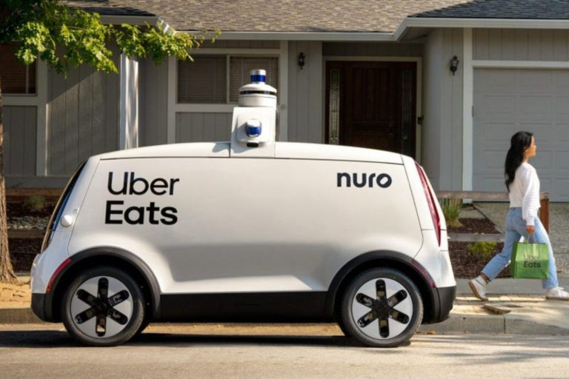

|  |  |  |  |
| --- | --- | --- | --- |
| **Terminal Value** |  | **Exit Multiple Method** | |
| LTM EV/EBITDA |  | 13.92 |  |
| Terminal Year EBITDA |  | 133420 |  |
| Terminal Value |  | 18,57,211 |  |
| Present Value of TV |  | 13,98,332 |  |
| **DCF Value of Firm / Operating Business Enterprise Value** | | **15,33,477** |  |
| Add: Non Operating Assets |  | 0 |  |
| **Total Value of Firm** |  | **15,33,477** |  |
| Less: Gross Debt & Debt Equivalents |  | -5924 |  |
| Add: Cash |  | 75621 |  |
| Less: Non Controling Interest |  | -946 |  |
| **DCF value of Common Equity** |  | **16,02,229** |  |
| No. of shares o/s-Diluted |  | 20102 |  |
| **DCF value per share** |  | **79.7** |  |

|  |
| --- |
| **UBER WACC CALCULATION** |
| ***( in USD Millions Except per share Data )***   |  |  |  |  |  | | --- | --- | --- | --- | --- | |  |  |  | 1 | BOTTOM UP | | **COST OF EQUITY** | **Column1** | **Column2** | **Column3** |  | | Particulars |  | NOTES | **VALUE** |  | |  |  |  |  |  | | Risk Free rate (%) |  |  | 4.2% |  | |  |  |  |  |  | | BETA |  |  | 0.45 |  | | Equity Risk premium |  |  | 5.00% |  | | Cost of Equity capital (%) |  |  | 6.5% |  | |

* WACC Sensitivity

The sensitivity below explores the Various WACC Scenarios ranging from 4% to 6%This study enables a thorough evaluation of how modifications in the company's valuation is impacted by the discount rate.

|  |  |  |  |
| --- | --- | --- | --- |
| **Cost Of Debt** |  |  |  |
| Particulars | notes |  | Value |
| Debt borrowing rate (%) |  |  | 5.8% |
| Expected income tax rate (%) |  |  | 27% |
| After-tax cost of debt (%) |  |  | 4.20% |

|  |  |  |  |  |
| --- | --- | --- | --- | --- |
| **Weighted average cost of capital** |  |  |  |  |
| **Particulars** | **Weight** | **Particulars** | **cost** | **Value** |
| Debt (%) | **6.70%** | **Cost of debt (%)** | **4.20%** |  |
| Equity (%) | 93.30% | **Cost of Equity (%)** | **6.5%** |  |
| **WACC** |  |  |  | **6.32%** |
|  |  |  |  |  |

|  |  |  |  |  |  |  |  |  |  |  |  |
| --- | --- | --- | --- | --- | --- | --- | --- | --- | --- | --- | --- |
|  |  | **WACC** | | | | | | | | | |
| **LTGR** | **74** | 5.8% | 6.05% | 6.30% | 6.55% | 6.80% | 7.05% | 7.30% | 7.55% | 7.80% |
| 1.00% | 52.1 | 52.1 | 52.1 | 52.1 | 52.1 | 52.1 | 52.1 | 52.1 | 52.1 |
| 1.25% | 54.0 | 54.0 | 54.0 | 54.0 | 54.0 | 54.0 | 54.0 | 54.0 | 54.0 |
| 1.50% | 56.2 | 56.2 | 56.2 | 56.2 | 56.2 | 56.2 | 56.2 | 56.2 | 56.2 |
| 1.75% | 58.5 | 58.5 | 58.5 | 58.5 | 58.5 | 58.5 | 58.5 | 58.5 | 58.5 |
| 2.00% | 61.0 | 61.0 | 61.0 | 61.0 | 61.0 | 61.0 | 61.0 | 61.0 | 61.0 |
| 2.25% | 63.8 | 63.8 | 63.8 | 63.8 | 63.8 | 63.8 | 63.8 | 63.8 | 63.8 |
| 2.50% | 66.9 | 66.9 | 66.9 | 66.9 | 66.9 | 66.9 | 66.9 | 66.9 | 66.9 |
| 2.75% | 70.4 | 70.4 | 70.4 | 70.4 | 70.4 | 70.4 | 70.4 | 70.4 | 70.4 |
|  | 3.00% | 74.3 | 74.3 | 74.3 | 74.3 | 74.3 | 74.3 | 74.3 | 74.3 | 74.3 |

|  |  |  |  |  |  |  |  |  |  |  |
| --- | --- | --- | --- | --- | --- | --- | --- | --- | --- | --- |
| **Exit Multiple** |  | **WACC** | | | | | | | | |
| **80** | 5.8% | 6.05% | 6.30% | 6.55% | 6.80% | 7.05% | 7.30% | 7.55% | 7.80% |
| 12.5x | 72.6 | 72.6 | 72.6 | 72.6 | 72.6 | 72.6 | 72.6 | 72.6 | 72.6 |
| 13.5x | 77.6 | 77.6 | 77.6 | 77.6 | 77.6 | 77.6 | 77.6 | 77.6 | 77.6 |
| 14.5x | 82.6 | 82.6 | 82.6 | 82.6 | 82.6 | 82.6 | 82.6 | 82.6 | 82.6 |
| 15.5x | 87.6 | 87.6 | 87.6 | 87.6 | 87.6 | 87.6 | 87.6 | 87.6 | 87.6 |
| 16.5x | 92.6 | 92.6 | 92.6 | 92.6 | 92.6 | 92.6 | 92.6 | 92.6 | 92.6 |
| 17.5x | 97.6 | 97.6 | 97.6 | 97.6 | 97.6 | 97.6 | 97.6 | 97.6 | 97.6 |
| 18.5x | 102.6 | 102.6 | 102.6 | 102.6 | 102.6 | 102.6 | 102.6 | 102.6 | 102.6 |
|  | 19.5x | 107.6 | 107.6 | 107.6 | 107.6 | 107.6 | 107.6 | 107.6 | 107.6 | 107.6 |
|  | 20.5x | 112.6 | 112.6 | 112.6 | 112.6 | 112.6 | 112.6 | 112.6 | 112.6 | 112.6 |

LTR Scenarios : reflects the Various Long term growth expectations ranging from 1% to 3% These scenarios reflect different long term growth expectations for the company's cash flows.

Risk Assessment : The analysis underscores that fluctuations in WACC (Weighted Average Cost of Capital) and Exit Multiple can have a notable impact on the projected share value. Elevated WACC or diminished Exit multiple may heighten the perceived investment risk.

Investment Decision: It is advisable for investors to thoroughly evaluate their risk tolerance and market outlooks while considering this sensitivity analysis

**TRADING COMPARABLES**

Similar firms offer a useful point of reference from which an estimated target company valuation may be derived. This is known as comparable company analysis. Some of the Peer Companies are :

****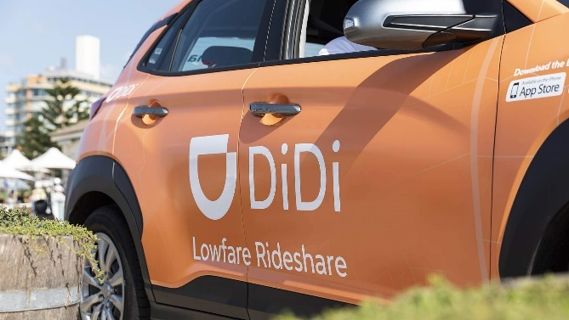

**METRICS AND PRICE :**

* EV / SALES : the Target Company’s Per share value is between Lower :20.5 and higher 36.1
* Only this metric is applicable especially for Company’s Like Uber which are into Internet based Transport , Delivery Business.
* When making investing selections, investors should carefully consider these ranges as well as other qualitative criteria, bearing in mind how risk factors and market dynamics may affect the stock price.

**APPENDIX**

* **Discounting Cash Flow.**

|  |
| --- |
| UBER DCF Valuation |
| *(in USD million except per Share Data)* |

|  |  |
| --- | --- |
| Valuation Date | 19-01-2025 |
| Latest Filing | 30-Sep-24 |
| Choose Discounting | Mid Year Discounting |
| WACC | 6.32% |

|  |  |  |  |  |  |
| --- | --- | --- | --- | --- | --- |
| Date of cash Flow | 12 Months 31-12-24 | 12 Months 31-12-25 | 12 Months 31-12-26 | 12 Months 31-12-27 | 12 Months 31-12-28 |
|  |  |  |  |  |  |
| EBIT | 142 | 33612 | 54701 | 90876 | 122885 |
| Tax Rate | 16% | 16% | 16% | 16% | 16% |
| **NOPAT** | **119** | **28157** | **45823** | **76128** | **102942** |
| Add: Depreciation and amortisation | 1622 | 2423 | 3818 | 6249 | 10535 |
| Add/Less: (Increase)/ Decrease in net working capital | -2235 | -3395 | -5477 | -9389 | -14837 |
| Less: Capital expenditure | -6202 | -6530 | -10885 | -18495 | -32079 |
| **Debt free cash flow (Free Cash Flows to Firm)** | **-6697** | **20655** | **33279** | **54493** | **66562** |
| Discount rate (%) | 7 | 7 | 7 | 7 | 7 |
| Full Period or Partial Period | 0.19 | 1.19 | 2.19 | 3.19 | 4.19 |
| Discounting Period-Year End |  |  |  |  |  |
| Discounting Period-Mid Year |  |  |  |  |  |
| Present value factor- Year end discounting | 1 | 0.92 | 0.86 | 0.81 | 0.75 |
| Present value factor- Mid year discounting |  |  |  |  |  |
| **Present value debt free cash flow** | **-6609** | **19051** | **28687** | **43901** | **50116** |
|  |  |  |  |  |  |
| Present value for explicit period | 135145 |  |  |  |  |

|  |  |  |  |  |  |  |  |  |  |  |
| --- | --- | --- | --- | --- | --- | --- | --- | --- | --- | --- |
|  |  | **WACC** | | | | | | | | |
| **LTGR** | **74** | 5.8% | 6.05% | 6.30% | 6.55% | 6.80% | 7.05% | 7.30% | 7.55% | 7.80% |
| 1.00% | 52.1 | 52.1 | 52.1 | 52.1 | 52.1 | 52.1 | 52.1 | 52.1 | 52.1 |
| 1.25% | 54.0 | 54.0 | 54.0 | 54.0 | 54.0 | 54.0 | 54.0 | 54.0 | 54.0 |
| 1.50% | 56.2 | 56.2 | 56.2 | 56.2 | 56.2 | 56.2 | 56.2 | 56.2 | 56.2 |
| 1.75% | 58.5 | 58.5 | 58.5 | 58.5 | 58.5 | 58.5 | 58.5 | 58.5 | 58.5 |
| 2.00% | 61.0 | 61.0 | 61.0 | 61.0 | 61.0 | 61.0 | 61.0 | 61.0 | 61.0 |
| 2.25% | 63.8 | 63.8 | 63.8 | 63.8 | 63.8 | 63.8 | 63.8 | 63.8 | 63.8 |
| 2.50% | 66.9 | 66.9 | 66.9 | 66.9 | 66.9 | 66.9 | 66.9 | 66.9 | 66.9 |
| 2.75% | 70.4 | 70.4 | 70.4 | 70.4 | 70.4 | 70.4 | 70.4 | 70.4 | 70.4 |
|  | 3.00% | 74.3 | 74.3 | 74.3 | 74.3 | 74.3 | 74.3 | 74.3 | 74.3 | 74.3 |

|  |  |  |  |  |  |  |  |  |  |  |  |
| --- | --- | --- | --- | --- | --- | --- | --- | --- | --- | --- | --- |
| **Exit Multiple** |  | **WACC** | | | | | | | | | |
| **80** | 5.8% | 6.05% | 6.30% | 6.55% | 6.80% | 7.05% | 7.30% | 7.55% | 7.80% |
| 12.5x | 72.6 | 72.6 | 72.6 | 72.6 | 72.6 | 72.6 | 72.6 | 72.6 | 72.6 |
| 13.5x | 77.6 | 77.6 | 77.6 | 77.6 | 77.6 | 77.6 | 77.6 | 77.6 | 77.6 |
| 14.5x | 82.6 | 82.6 | 82.6 | 82.6 | 82.6 | 82.6 | 82.6 | 82.6 | 82.6 |
| 15.5x | 87.6 | 87.6 | 87.6 | 87.6 | 87.6 | 87.6 | 87.6 | 87.6 | 87.6 |
| 16.5x | 92.6 | 92.6 | 92.6 | 92.6 | 92.6 | 92.6 | 92.6 | 92.6 | 92.6 |
| 17.5x | 97.6 | 97.6 | 97.6 | 97.6 | 97.6 | 97.6 | 97.6 | 97.6 | 97.6 |
| 18.5x | 102.6 | 102.6 | 102.6 | 102.6 | 102.6 | 102.6 | 102.6 | 102.6 | 102.6 |
|  | 19.5x | 107.6 | 107.6 | 107.6 | 107.6 | 107.6 | 107.6 | 107.6 | 107.6 | 107.6 |
|  | 20.5x | 112.6 | 112.6 | 112.6 | 112.6 | 112.6 | 112.6 | 112.6 | 112.6 | 112.6 |